Bosnian refugee tells of odyssey to freedom

Allan Thompson Toronto Star. Toronto Star; Toronto, Ont. [Toronto, Ont]25 Jan 1993: A6.

Illustration
Senad Kuburas with daughter Melita and son Meldun

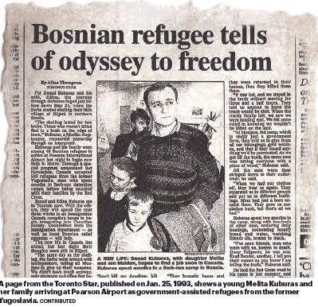

For Senad Kuburas and his wife, Edina, the journey through darkness began just before dawn May 31, when the Serbs started shelling their little village of Biljani in northern Bosnia.
"The shelling lasted for two hours. Those who weren't killed fled to a bush on the edge of town," Kuburas, a Muslim shopkeeper, recounted yesterday through an interpreter. Kuburas and his family were among 46 Bosnian refugees to arrive at Pearson International Airport last night to begin new lives in Metro. Through a special program announced last November, Canada accepted 500 refugees from the former Yugoslavia, men who spent months in Serb-run detention camps before being reunited with their families by the Red Cross.
Senad and Edina Kuburas are in Toronto now. With the others, they will spend the next three weeks in an Immigration Canada reception house to begin integrating into Canadian society. Counsellors from the immigration department - as well as local Bosnian relief agencies - will help. The new life in Canada lies ahead, but last night their thoughts were still in Biljani.
"The same day as the shelling, the Serbs went around with loudspeakers, telling all Muslims to give up their weapons. We didn't have much anyway, only shotguns and rifles that belonged to those who were hunters," Kuburas said.
The villagers turned in their weapons. Then about 100 soldiers came with trucks and picked up all the men, promising not to harm them.
"I was taken to a place where they asked me what I owned, then sent me home," Kuburas said. "But a week later they came back, came to my house saying they had an order to search.
"They pushed my wife and children into the corner of the room. A man with a shotgun pointed it at my father, and told me to hand over all our money, our deutschmarks. I had only 150 and he didn't believe that was all I had. He put a gun to my daughter's head and said he would shoot her if I didn't give more money.
"I swore that's all I had. 'Don't kill my daughter, kill me,' " I said. "Then another man came. He was a Serb, one of my neighbors. I knew him. He told me just to give the money.
" 'Hey, we grew up together, I have no idea what's going on,' I told him. He told me another group of soldiers was coming, and that they were going to kill me. I panicked, sent my wife and kids to the neighbor's house.
"Then the soldiers came and knocked on my door. They told me to come out. We came out, me and my old father. They said, 'Leave the old man here.' " Kuburas said he never saw his father again.
"They took me and some others to the outskirts of town. We waited there three or four hours while they went through the village, looting. One of my friends was killed there," he said.
"They brought buses and took us to the high school, where we spent three days. They gave us only one small sandwich to eat from Friday to Sunday.
"Then they brought big trucks. We knew that if they took us east we'd be saved, but if they drove us north, we'd all be killed.
"When they were calling our names they told us to put our heads down and our hands on our backs, they were kicking us and hitting us with rifle butts as we went into the trucks. There was one guy with a big piece of wood, he hit everyone on their way into the truck.
"They were telling us we were idiots, that we didn't deserve to live, that they were going to kill us all. Some of the 200 of us weren't put in the trucks. They were left behind, about 80 of them. We heard they were returned to their houses, then they killed them there.
"It was hot, and we stayed in the truck without moving for three and a half hours. They told us anyone to leave the truck would be shot. When the trucks finally left, we saw we were heading east. We felt some relief in knowing we wouldn't be killed on the spot.
"At Manjaca, the camp, which is really just a government farm, they told us to give them all our belongings, gold watches, and that if they found anything we'd be persecuted. As we got off the truck, the same man was hitting everyone with a piece of wood," Kuburas said.
All the men were then stripped down to their underwear, he said.
"When we had our clothes off, they beat us again. They separated us in different groups and put us in different buildings. Mine had just a bare cement floor. They gave us our clothes back, but that's all we had."
Kuburas spent two months in the camp, along with hundreds of other men, enduring daily beatings, consuming mostly bread and water, watching friends die, beaten to death.
"I've seen friends, men who were with us, beaten to death. Omer Felipovic, he was one. Esad Bander, another. I tell you their names so you know I am telling the truth," Kuburas said.
He said the Red Cross went to his camp in late summer, and conditions improved. There were fewer beatings.
And there was news from his wife and children, who had been in Croatia being supported by a humanitarian organization.
There was also news that on July 10, 300 of the old people left behind in the village had been taken from their homes and executed.
"My mother escaped to Zagreb. But my father, he was killed," Kuburas said.
"The Red Cross asked us if we wanted to go from the camps. We'd heard so much about Canada. Canada was taking people with families," he said.
"We were told Canada is a big country, only 27 million people, so it still needs population here.
"I hope I can find a job and settle very quickly."

-30-

